ATP – Driver Setup Procedure

ATP – Driver setup procedure

Document version: 1.0

Release date: 4 October 2017

# Document releases

|  |  |  |
| --- | --- | --- |
| **Release date** | **Version** | **Changes** |
| 4 October 2017 | 1.0 |  |

# When to use this document

This document is used to setup the new payment driver in the ATP Platform.

# Destination

This document is intended for internal usage.

# Terminal Connection Setup

Before connecting the terminal make sure you have the following information from Ingenico: Terminal ID, Communication Server 1 and Communication Server 2.

To use the terminal you need to connect it to the kiosk.

Check in device manager if the device is recognized by windows or appears in Other devices

Device Manager 
Eile Action Yieuu Help 
ACRELEC-VGG53g•d 
Audio inputs and outputs 
Computer 
Disk drives 
Display adapters 
Human Interface Devices 
ca IDE ATA/ATAPI controllers 
Keyboards 
Mice and other pointing devices 
Monitors 
Netouork adapters 
Other devices 
Unknowun device 
Pmts .COM & LPT) 
Communications Port (COMI) 
Print queues 
Processors 
Sound, video and game controllers 
Storage controllers 
System devices 
Universal Serial Bus controllers 

If it appears under Other devices you need to install the driver located at **C:\Acrelec\Core\Peripherals\Payments\[PaymentName]\[PaymentVersion]\WindowsDriver**

When installing the driver, make sure that you select the correct Ingenico terminal

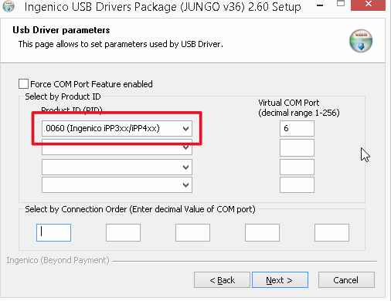

After install, a new COM port should be available in Device Manager:

Device Manager 
Eile Action Yieuu Help 
ACRELEC-VGG53g•d 
Audio inputs and outputs 
Computer 
üisk drives 
Dispiay adapters 
Human Interface Devices 
ca IDE ATA/ATAPI controllers 
Keyboards 
Mice and other pointing devices 
Monitors 
B.let,n'ork adapters 
Ports .COM & LPT) 
Communications Port (COMI) 
Sagem Telium Comm Port (COM3) 
Print queues 
Processors 
Sound, video and game controllers 
Storage controllers 
Systern devices 
Universal Serial Bus controllers 

# ATP SETUP

Open the Admin and login.

Go to the “Peripherals” Tab > select one “Payment” Tab and select “UK_IPP350”.

Fill the required fields:

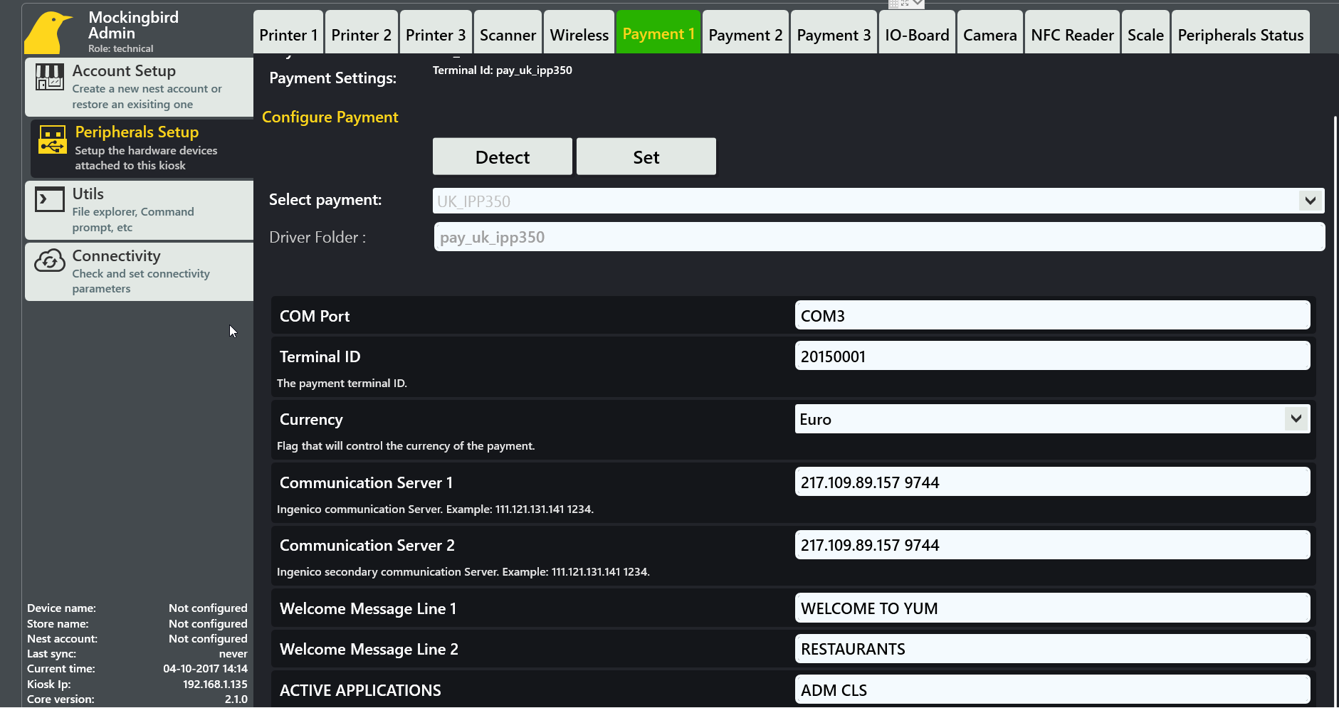

COM Port is the com port where the device is connected

Terminal ID should be provided by Ingenico

Currency is the used currency

Communication Server 1 should be provided by Ingenico

Communication Server 2 should be provided by Ingenico

Welcome message line 1/2 message that is displayed on the terminal screen

Active applications are the applications that will be active after the initialization of the terminal

**TEST ENVIRONMENT SETTINGS**

When configuring the device in LAB the following settings must be used:

Terminal ID: 20150001

Communication Server 1: 91.208.214.106 9744

Communication Server 2: 91.208.214.106 9744

**These settings are NOT supposed to be used in real environments!**